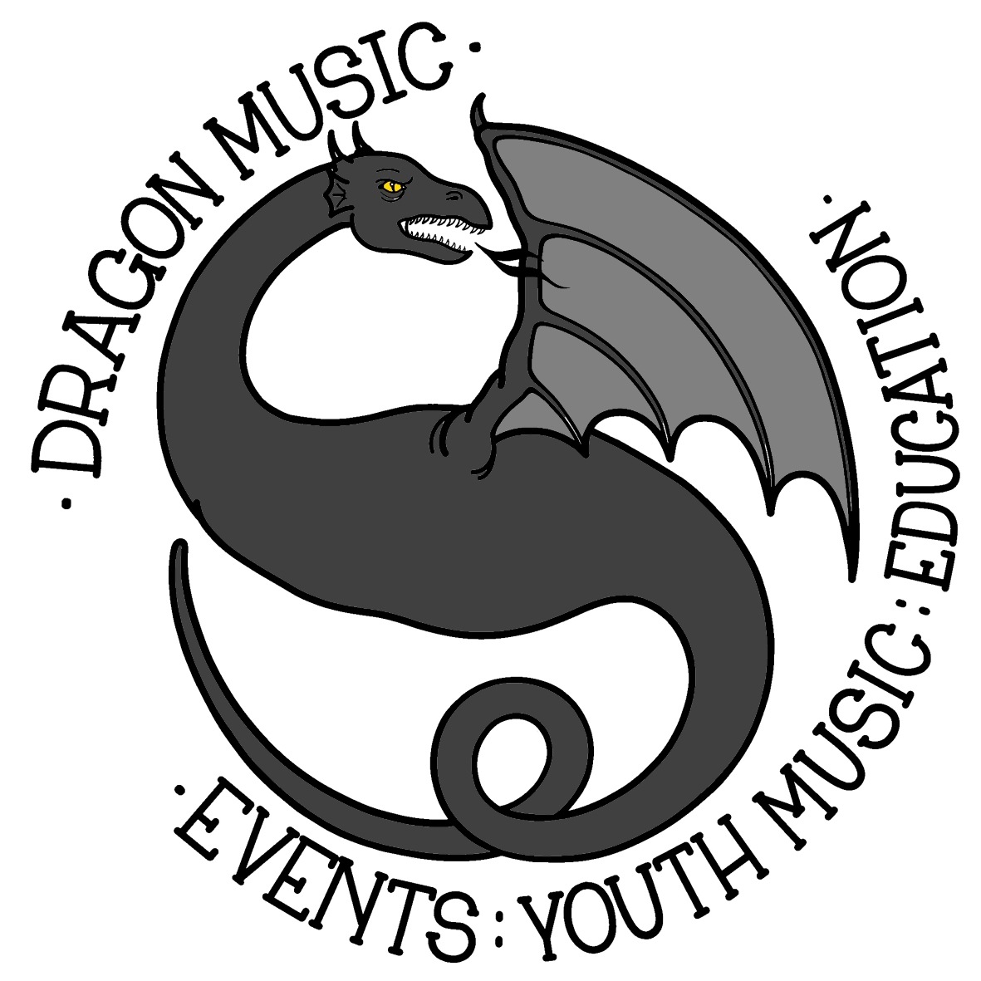 | Colwall Rock School  Enrolment Form  Trial term of 5 weeks costing £75.  Subsequent terms will be 10 weeks at a cost of £150.
Spring 2019 dates: 02/03/19 FREE taster day
09/03/19 : 16/03/19 : 23/03/19 : 30/03/19 : 06/04/19
Running times: 15:00 – 17:00

Name and age of Student/s:
Instrument:
(eg guitar/vocals etc)
Address:
Postcode:
E-mail:
Phone no:
Name of parent / guardian:

For routine communications we will use e-mail unless you specify otherwise.

To pay by BACS please tick the box and use the student’s surname as the reference:
Sort code: 05-09-42
Account: 57742319

I / we enclose payment of £75.00 by cheque made payable to ‘Dragon Music’.

Contact name and number: ______________________________________________________
(no need if details same as above)

Dragon Music
Suite 116, 79 Friar Street, Worcester, WR1 2NT.

